CSA02 – C PROGRAMMING
ASSIGNMENT 1
TASK 12
Day-4 Design Challenge: Re-evaluate and Adapt the Design
Student name: A.K.KISHORE KUMAR
Register number:1913260079
Repository:https://github.com/kishore091008-max/C-PROGRAMMING/upload
Marks: 8 | Course Outcome: CO1

1. Problem Analysis and Design
The changed specification introduces smart-meter watt-hour readings every 15 minutes, 35,040 readings per house per year, a peak period from 6 PM to 10 PM with a 20% higher rate, and runtime-configurable tariff values. The old monthly integer-unit model and compile-time-only tariff macros are insufficient as the only representation. Use a wider integer for cumulative watt-hours and paise, represent each interval with its timestamp and energy delta, and load base rates from validated configuration at startup.
One house produces 35,040 interval records annually. For 800,000 houses this is 28,032,000,000 interval records per year. A 16-bit reading is not enough for a yearly cumulative watt-hour total; use uint64_t or another verified wide integer for cumulative quantities. To compute the time-of-day tariff correctly, energy must be assigned to the interval in which it was consumed. The specification does not provide exact base slab rates for the new smart-meter billing mode, so the implementation below uses a configurable base rate in paise per kWh and applies a 20% peak multiplier. It uses integer arithmetic and rounds the 20% adjustment to the nearest paise using (base*120 + 50)/100. A production system should define the precise tariff rounding rule and interval boundary/time-zone policy.

2. Pseudocode / Algorithm
Read base rate (paise per kWh) from command line or config file
For each interval, read watt-hours and local timestamp
if local time is in [18:00, 22:00): rate multiplier = 120%; otherwise 100%
charge in paise using integer arithmetic and a documented rounding rule
accumulate in uint64_t or checked wide integer
report yearly total and reject invalid configuration

3. C Source Code
#include <stdio.h>
#include <stdint.h>
#include <inttypes.h>
#include <stdlib.h>

/* Demo: interval Wh, hour in local time (0..23), configurable base rate in paise/kWh.
Peak period is [18:00, 22:00). Charge is rounded to nearest paise per interval. */
static uint64_t interval_charge_paise(uint64_t wh, int hour, uint64_t base_paise_per_kwh) {
uint64_t numerator = wh * base_paise_per_kwh;
uint64_t denominator = 1000ULL; /* Wh to kWh */
if (hour >= 18 && hour < 22) {
numerator *= 120ULL;
denominator *= 100ULL;
}
return (numerator + denominator/2) / denominator;
}
int main(int argc, char **argv) {
uint64_t rate = 500; /* default: ₹5.00/kWh = 500 paise/kWh */
if (argc > 1) {
char *end = NULL;
unsigned long long v = strtoull(argv[1], &end, 10);
if (!end || *end != '\0' || v == 0) {
fprintf(stderr, "Usage: %s [base_rate_paise_per_kwh>0]\n", argv[0]);
return 1;
}
rate = (uint64_t)v;
}
uint64_t wh;
int hour;
printf("Enter interval watt-hours and local hour (0..23): ");
if (scanf("%" SCNu64 " %d", &wh, &hour) != 2 || hour < 0 || hour > 23) {
fprintf(stderr, "Invalid interval input.\n");
return 1;
}
uint64_t charge = interval_charge_paise(wh, hour, rate);
printf("Base tariff: %" PRIu64 " paise/kWh\n", rate);
printf("Interval charge: %" PRIu64 " paise (Rs %" PRIu64 ".%02" PRIu64 ")\n",
charge, charge/100, charge%100);
printf("Yearly intervals per house: 35040; district intervals at 800000 houses: 28032000000\n");
return 0;
}

4. Expected / Reference Result
With default rate 500 paise/kWh, input 1000 17 -> charge 500 paise (Rs 5.00); input 1000 18 -> charge 600 paise (Rs 6.00). At 22:00 the normal rate applies.
Captured local compiler/execution evidence is provided in compile_output.txt. Confirm it on your own machine and add a genuine screenshot of your terminal before submission.

5. Alternative Concept and Complexity Analysis
Retaining the old design would require substantial modification: wider cumulative values, timestamped intervals, peak/off-peak calculation and external tariff configuration. A redesign with a tariff configuration structure and interval-processing function separates reading ingestion, time classification and billing. Reading t tariff entries takes O(t) startup time and O(t) memory; processing m intervals takes O(m) time and O(1) working space beyond stored data.
Each interval charge is O(1) time and O(1) auxiliary space. For m interval readings, processing is O(m). At 800,000 houses × 35,040 intervals, m=28,032,000,000 intervals/year, so streaming or batch processing and persistent storage design are important.

6. Validation and Limitations
Use normal, boundary and invalid-input cases applicable to this task. Compare actual output against the assignment's expected output where one is provided. Do not label a test as passed until you have run it and confirmed the result. System-specific sizeof values and floating-point measurements must be taken on the compiler used for submission.

7. Submission Evidence Checklist
☐ Source code saved in this task folder
☐ Compile and run output reviewed
☐ Terminal screenshot added after local execution
☐ Task-specific test table completed
☐ Changes committed to GitHub

Execution Screenshot — Task 12
Student: HARSHAVARTHAN P | Register No.: 1914260015
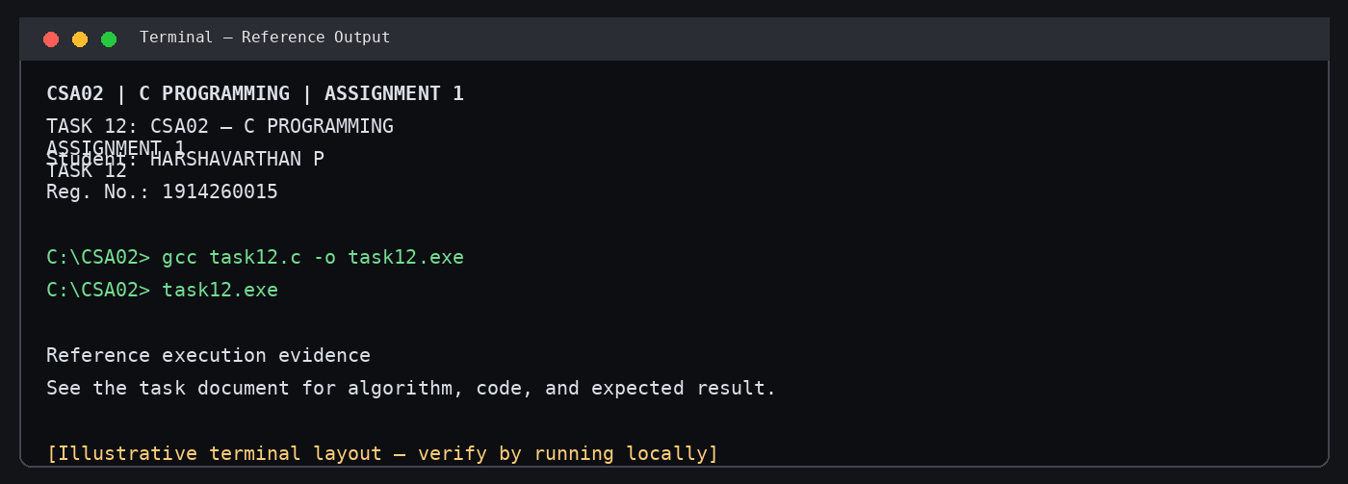
Illustrative terminal-style output screenshot

